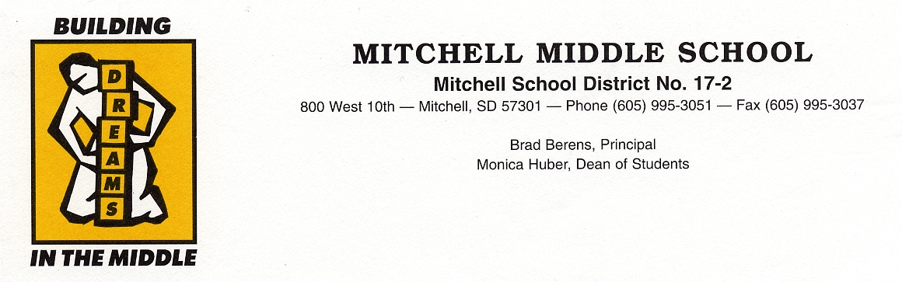

TO: NCLB Team Members – Mitchell Middle School

FROM: Brad Berens

RE: Getting started

Dear Team Members:

As the first semester and another calendar year come to a close I am anxious that we have yet to begin our process but encouraged that we are about to take the first step. At this point I realize we have more questions than answers and it will take a concerted effort to get the team moving forward.

From the beginning I have tried to conceptualize the overall idea of what our NCLB plan will center around. Simply put our plan must center on improving the academic standing of all students in the Mitchell Middle School. How do we get there? We will start by taking a look at six issues:

- Is our school progressing as quickly as it should? If not, how can we improve?
- Why are some groups of students having less success than others, and what can we do about it?
- How can we do a better job of involving parents and the wider community in our efforts to help our school succeed?
- How should we provide teachers the support they need to help their students succeed and meet NCLB teacher requirements?
- How can we maintain momentum with our current school improvement strategies in the midst of NCLB requirements?
- How can we use NCLB as an opportunity to improve?

We will use these as a starting point for discussion. I anticipate that we may add other issues as we work through our plan. Because NCLB is relatively new, role model NCLB plans are not available. I was able to locate information on an initiative titled “Schools to Watch” and I have included an article from the Internet about the program. If you have time to visit the site you will find some valuable information about four middle schools that have been identified as “Schools to Watch.” Visit supporting Site

The first meeting for the NCLB team will be held Thursday January 15 at the Middle School Library and will begin at 5:30 pm. We will try to keep this meeting and all others to one hour or less.

Our NCLB team consists of middle school staff, middle school parents, and community members at large. As stated earlier our goal is to develop a plan that will improve the academic standing of all students in the Mitchell Middle School. Through healthy discussion and diligence I believe we will be successful. On behalf of the students, staff and myself I want to thank you for being a part of the Middle School NCLB team.

Sincerely;

Brad Berens

